Telluride Conference on Epithelial Physiology and Cell Biology
Organizers: Tom Kleyman, My Helms, Pete Snyder
Telluride Intermediate School (TSRC)
725 West Colorado Avenue
____________________________________________________________________________

Monday July 31, 2017
12:30-1:30 PM Chris Benson
1:30-2:30 PM Michelle Gumz
2:30-3:00 PM Break-refreshments
3:00-4:00 PM Tom Kleyman
4:00-5:00 PM Arohan Subramanya
Tuesday August 1, 2017
7:30 AM Breakfast at TSRC
8:00-9:00 AM David Pearce
9:00-10:00 AM David Ellison
10:00-10:30 AM Break-refreshments
10:30--11:30 AM Aylin Rodan
11:30-12:30 PM Carolyn Ecelbarger

6:00-7:00 PM Town talk
Telluride Conference Center in
Mountain Village
“Molecules and Light: The Story of Life, Death, and Our Quest for Knowledge"
Anna Krylov, University of Southern California

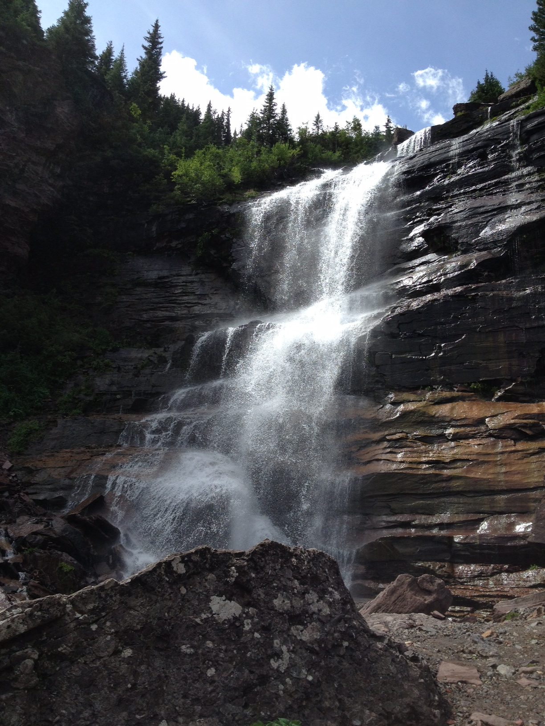

Wednesday August 2, 2017
7:30 AM Group Science Hike

6:00 – 9:00 PM Picnic

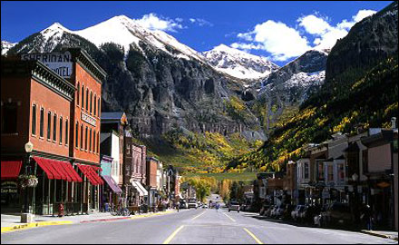

Thursday August 3, 2017
12:30-1:30 PM My Helms
1:30-2:30 PM Daniela Rotin
2:30-3:00 PM Break-refreshments
3:00-4:00 PM Doug Eaton
4:00-5:00 PM Ossama Kashlan

Friday August 4, 2017
7:30 AM Breakfast at TSRC
8:00-9:00 AM Abdel Alli
9:00-10:00 AM Heping Ma
10:00-11:00 AM Pete Snyder
11:00-11:30 AM Wrap Up

